“GRAPHICAL PASSWORD AUTHENTICATION SYSTEM”
A Mini Project report Submitted in partial fulfilment
of the requirement for the award of degree of
BACHELOR OF TECHNOLOGY
in
CSE-(Cyber Security)
Submitted By:
Y.BUNNY (23U51A6244)
M.AKSHITHA (23U51A6223)
P.SHANKAR (23U51A6232)

Under the Guidance of
Prof. K PRAVEEN
(Associate Professor)



CSE-(Cyber Security)
Drk College of Engineering and Technology
(Affiliated to JNTU University, Hyderabad)
Bowrampet, Hyderabad-500043
2025-2026

CERTIFICATE
This is to certify that the project report entitled “GRAPHICAL PASSWORD AUTHENCATION SYSTEM” is being submitted by:

Y.BUNNY (23U51A6244)
M.AKSHITHA (23U51A6223)
P.SHANKAR (23U51A6232)

To JNTUH, Hyderabad, in partial fulfilment for the award of the Degree of Bachelor of Technology in Computer Science and Engineering (CYBER SECURITY) to the Jawaharlal Nehru Technological University is a record of Bonafide work carried out by them under my guidance and supervision. The results embodied in this project report have not been submitted to any other University or Institute for the award of any Degree.

Prof. DURGA PRASAD KAVADI
Head of the Department
Dept. Of CSE (CYBER SECURITY)
INTERNAL EXAMINER
Prof. K. PRAVEEN
Associate Professor
Dept. of CSE(CYBER SECURITY)

EXTERNAL EXA

EXTERNAL EXAMINER

ACKNOWLEDGEMENT

The report would not be complete without mentioning certain individuals whose guidance and encouragement have been of immense help to complete this thesis.
We express a deep sense of gratitude to our guide Prof. K PRAVEEN, Associate Professor, Department of CSE(CYBER SECURITY), for her able guidance and cooperation throughout our project. We are highly grateful to her for providing all the facilities for the completion of the project work.
We are very thankful to Prof. DURGA PRASAD KAVADI, Professer and HOD, Department of CSE(CYBER SECURITY), for providing the necessary resources for successful completion of the project work.
We would also like to express our gratitude Prof. Gnaneswara Rao Nitta, Principal of DRK Institute of Science and Technology, for his valuable guidance and Encouragement gave to us throughout this project.
We render our respected sir D.B. Chandra Sekhar Rao, Chairman of DRK Group of Institutions, for his initiative in creating a conducive atmosphere in which we could Complete the course work and project work successfully.
We would like to thank our parents and friends, who have the greatest contributions in all our achievements, for the great care and blessings in making us successful in all our endeavour’s.

Yadranti Bunny Miryala Akshitha
23U51A6244 23U51A6223
Dept. of CSE (CYBER SECURITY) Dept. of CSE (CYBER SECURITY)

Pulluri Shankar
23U51A6232
Dept. of CSE (CYBER SECURITY)

ABSTRACT

With the rapid growth of digital systems and online services, ensuring secure user authentication has become a critical challenge. Traditional text-based passwords are widely used but suffer from several limitations such as vulnerability to brute-force attacks, phishing, zthis project proposes a Graphical Password Authentication System, which enhances security and usability by leveraging human visual memory.
The proposed system allows users to authenticate themselves using images, patterns, or graphical elements instead of conventional alphanumeric passwords. Since humans tend to remember images more easily than text, graphical passwords provide better memorability while maintaining strong security. The system is designed to resist common attacks by incorporating features such as randomized image placement and user-specific image selection.
In conclusion, the Graphical Password Authentication System offers a promising alternative to traditional authentication methods by combining enhanced security with improved usability. This approach can be effectively applied in various domains such as banking systems, mobile applications, and secure login platforms, thereby contributing to safer digital interactions.

TABLE OF CONTENTS
1.INTRODUCTION
1.1 PURPOSE
1.2 PROBLEM STATEMENT
2.SYSTEM SPECIFICATIONS
2.1 HARDWARE REQUIREMENTS
2.2 SOFTWARE REQUIREMENTS
3.SOFTWARE AND HARDWARE SPECIFICATIONS
3.1 REQUIREMENT ANALYSIS
3.2 REQUIREMENT SPECIFICATIONS
3.2.1 FUNCTIONAL REQUIREMENTS
3.2.2 SOFTWARE REQUIREMENTS
3.2.3 HARDWARE REQUIREMENTS
4.LITERATURE SURVEY
5.1 EXISTING SYSTEM
5.2 PROPOSED SYSTEM
6.MODULES
6.1 MODULES
6.2 MODULES DESCRIPTION
7.SYSTEM DESIGN
7.1 TRANSFORMER-BASED STOCK PREDICTION SYSTEM ARCHITECTURE
7.2 DATA PREPARATION AND FEATURE ENHANCEMENT PHASE
7.3 MODEL TRAINING AND FORECASTING PROCESS (USING TRANSFORMER)
7.4 DATA FLOW DIAGRAM FOR STOCK PREDICTION SYSTEM
8. SOURCE CODE
9.SYSTEM STUDY
9.1 FESABILITY STUDY
9.1.1 FESABILITY STUDY FACTORS
9.2 FESABILITY STUDY METHODOLOGY
10.SYSTEM TESTING
10.1 TYPES OF SYSTEM TESTS
10.2 SYSTEM TEST METRICES
11.OUTPUT SCREENS
12.FURTHER ENHANCEMENTS
13.REFERENCES

1. INTRODUCTION
In the modern digital era, the rapid growth of technology and internet usage has led to an increased demand for secure authentication systems. Almost every application, whether it is banking, social media, or educational platforms, requires users to authenticate themselves before accessing sensitive information. Traditionally, authentication systems rely on text-based passwords, where users create and remember a combination of characters, numbers, and symbols. However, these methods have several drawbacks, such as difficulty in remembering complex passwords, tendency to reuse passwords across multiple platforms, and vulnerability to various cyber-attacks like brute force attacks, dictionary attacks, shoulder surfing, and phishing.
To address these challenges, researchers have introduced alternative authentication techniques, among which Graphical Password Authentication has gained significant attention. This method uses images, patterns, or visual elements as passwords instead of plain text. The main idea behind graphical passwords is based on the psychological principle that humans have a better ability to remember visual information compared to textual information. As a result, users can create stronger and more memorable passwords without compromising usability.
Graphical password systems can be broadly classified into three categories: recognition-based, recall-based, and hybrid methods. In recognition-based systems, users identify and select images from a set of options. In recall-based systems, users reproduce a drawing or click specific points on an image. Hybrid systems combine both approaches to enhance security. Each method provides different levels of security and usability, making them suitable for various applications.
The main objective of this project is to design and implement a secure and efficient graphical password authentication system. In this system, users can register by selecting a sequence of images or specific points on an image, which will act as their password. During login, the system verifies the user by matching the selected images or points with the stored data. This approach reduces the risk of common password attacks and enhances overall system security.
Furthermore, the proposed system focuses on improving user experience by making the authentication process simple, intuitive, and reliable. It also aims to minimize the chances of unauthorized access while ensuring that legitimate users can easily remember and use their passwords. Additional security measures, such as limiting login attempts and secure data storage, can also be incorporated to strengthen the system.
In conclusion, this project highlights the importance of moving beyond traditional password systems and adopting innovative authentication techniques. Graphical password authentication provides a promising solution by combining security with usability, making it a suitable approach for modern digital applications.
1.Fundamental Analysis:
The Graphical Password Authentication system is designed to enhance security and usability by using images instead of traditional text-based passwords, based on the idea that humans can remember visuals more easily and accurately. This approach helps in creating stronger and more memorable passwords while reducing common security risks. The system works by allowing users to select images or points on an image during registration and verifying them during login through secure storage and matching mechanisms.
- Improves security by reducing risks of attacks like brute force and phishing.
- Enhances usability by making passwords easier to remember through visual elements.
2. Technical Analysis:
The Graphical Password Authentication system is developed using a client-server architecture that integrates both front-end and back-end technologies to ensure secure and efficient user authentication. The front-end is designed using user-friendly interfaces (such as HTML, CSS, and JavaScript) to allow users to interact with graphical elements like images or clickable points. The back-end is responsible for processing user inputs, verifying credentials, and managing sessions, typically implemented using programming languages like Python, Java, or PHP. A database system (such as MySQL) is used to securely store user data, where graphical passwords are often converted into encoded or hashed formats to maintain confidentiality. The system also incorporates validation mechanisms, coordinate matching algorithms (for click-based passwords), and security features such as input verification, login attempt limits, and session handling. Overall, the technical design ensures accuracy, data security, and smooth performance while providing an effective graphical authentication process.

1.1 Purpose
The main purpose of the Graphical Password Authentication project is to provide a more secure and user-friendly alternative to traditional text-based password systems. It aims to reduce common security risks such as password guessing, brute force attacks, and phishing by using images or graphical elements for authentication. By leveraging human visual memory, the system helps users create strong passwords that are easier to remember and harder for attackers to crack.
Additionally, the project focuses on improving the overall user experience by making the login process simple and intuitive while maintaining high security standards. It also aims to demonstrate an effective authentication mechanism that can be applied in modern applications to protect sensitive user data.
Furthermore, the project aims to explore and implement advanced security features such as secure data storage, login attempt restrictions, and resistance to shoulder surfing attacks. It also provides a foundation for future enhancements in authentication systems, encouraging the adoption of innovative techniques that balance both security and usability in real-world applications
1.2 Problem Statement
Problem Statement
In the current digital era, user authentication plays a crucial role in protecting sensitive information across various applications such as banking systems, social media platforms, and educational portals. Most of these systems rely on traditional text-based passwords for authentication. However, these passwords present several challenges related to both security and usability. Users often create weak passwords that are easy to guess or reuse the same password across multiple platforms, increasing the risk of unauthorized access. At the same time, strong passwords are difficult to remember, leading users to write them down or store them insecurely, which further compromises security.
Another major issue with text-based passwords is their vulnerability to common cyber-attacks such as brute force attacks, dictionary attacks, phishing, and shoulder surfing. Attackers can easily exploit predictable password patterns or trick users into revealing their credentials. As a result, many systems experience security breaches, leading to data theft, privacy violations, and financial losses. These limitations highlight the need for a more secure and reliable authentication mechanism that can overcome the weaknesses of traditional password systems.
In addition to security concerns, usability is also a significant problem in existing authentication methods. Users often forget complex passwords, which leads to frequent password reset requests and inconvenience. This not only affects user experience but also increases the workload on system administrators. Therefore, an ideal authentication system should provide both strong security and ease of use without placing a burden on users.
To address these challenges, there is a need to develop an alternative authentication approach that enhances security while maintaining usability. Graphical Password Authentication emerges as a promising solution by allowing users to authenticate using images, patterns, or graphical inputs instead of text. This approach leverages the human ability to remember visual information more effectively, reducing the chances of forgetting passwords while making it difficult for attackers to guess or replicate them.
The problem addressed in this project is to design and implement a secure, efficient, and user-friendly graphical password authentication system that minimizes the risks associated with traditional passwords. The system should be capable of protecting user data from unauthorized access, resisting common cyber threats, and providing a smooth and reliable authentication experience. By solving these issues, the project aims to improve both the security and usability of authentication systems in modern applications.

2. SYSTEM REQUIREMENTS
Hardware:
- Processor: Intel i3 or above
- RAM: Minimum 4 GB
- Storage: 10 GB free disk space
- Hard Disk: 500 GB or above
- Monitor: Standard display monitor
- Keyboard and Mouse: For user interaction
- Internet Connection: For downloading tools and libraries
Software:
- Operating System: Microsoft Windows 10 or above
- Programming Language: Python3.8 and above
- Database: Fikr system
- Web Browser: Google Chrome or equivalent

3. SOFTWARE AND HARDWARE SPECIFICATIONS
3.1 Requirement Analysis
The Requirement Analysis for the Graphical Password Authentication system focuses on identifying the needs and functionalities required to develop a secure and user-friendly authentication mechanism. The system must enable users to register and log in using graphical elements such as images or click points instead of traditional text-based passwords. It should accurately capture user input, store it securely in a database, and verify it during the authentication process. The system must also handle invalid login attempts, provide appropriate error messages, and ensure that only authorized users can access the system.
In addition to functionality, the system must satisfy important quality requirements such as security, usability, performance, and reliability. It should protect user data through secure storage techniques like encryption or hashing, and prevent unauthorized access through measures such as limiting login attempts. The interface should be simple and easy to use, allowing users to interact with graphical elements without confusion. The system should also perform efficiently, respond quickly, and be capable of handling multiple users while maintaining data integrity and consistency.
3.2 REQUIREMENT SPECIFICATION
3.2.1 Functional Requirements
The system must allow users to register by selecting a sequence of images or specific points on an image as their graphical password. It should provide a login feature where users can authenticate by selecting the same images or points in the correct order. The system must validate user inputs accurately and grant or deny access based on authentication results. It should also store user credentials securely in a database and provide error messages for incorrect attempts. Additionally, features like limiting login attempts and allowing password reset options should be included.

3.2.2 Software Requirements
Technologies and Tools Used:
Component | Specification
Programming Language | Python 3.8 or above
Libraries | OpenCV, NumPy, Tkinter / Flask
Model/Technique | Graphical Password Authentication (Image/Click-based)
Data Storage | MySQL / SQLite Database
IDE/Notebook | VS Code / PyCharm
Operating System | Windows 10/11, Ubuntu, or macOS
3.2.3 Hardware Requirements
Component |  | Specification
Processor |  | Intel i3 or above
RAM |  | Minimum 4GB (8GB recommended)
Storage |  | Minimum 20GB free space
Display |  | Standard monitor (1366×768 resolution or higher)
InputDevices |  | Keyboard and Mouse
System Type |  | 64-bit Computer System
Network |  | Internet connection for web-based access (optional)
Processor | Intel Core i5/i7 or AMD Ryzen 5+ (8th Gen or higher recommended)
RAM | Minimum 8 GB (Recommended: 16 GB or more for model training)
Storage | Minimum 128 GB SSD (Recommended: 256 GB+ with free space for datasets)
GPU | NVIDIA GPU with CUDA support (e.g., GTX 1650, RTX 3060) – Optional but recommended
Display | HD screen for visualizations and user interface

4. LITERATURE SURVEY
Graphical password authentication has emerged as a promising alternative to traditional text-based passwords due to its potential for enhanced memorability and security. Early studies, such as those by Jermyn et al. (1999), introduced the concept of graphical passwords and highlighted the advantages of image-based authentication over alphanumeric passwords. Their work showed that users tend to remember images more easily than complex strings of characters, which improves both usability and recall.
Wiedenbeck et al. (2005) further developed this concept with PassPoints, a system where users select points on an image as their password. Their longitudinal evaluation demonstrated that graphical passwords could be practical for real-world use, though patterns could be predictable if users selected obvious points like corners or central areas.
Research by Davis, Monrose, and Reiter (2004) analyzed user behavior in selecting graphical passwords and highlighted vulnerabilities to attacks such as shoulder surfing and hotspot patterns. Their work emphasized the need for secure design practices that prevent predictable choices. Biddle, Chiasson, and van Oorschot (2012) conducted a comprehensive review of graphical passwords over twelve years, concluding that while graphical systems improve usability, careful consideration of security trade-offs is essential.
Recent advancements focus on integrating artificial intelligence and adaptive methods to enhance security. For instance, Abdelrahman and Moustafa (2020) explored AI-based methods to analyze user interaction patterns and detect anomalies, improving the system’s resistance to unauthorized access. Similarly, image recognition-based approaches, as discussed by Tao et al. (2017), provide dynamic password mechanisms where images can change or adapt to reduce vulnerabilities like replay attacks.
In addition to security considerations, usability studies, such as those by Tari, Ozok, and Holden (2006), show that graphical passwords reduce cognitive load and improve user satisfaction compared to complex text-based passwords. Moreover, combining graphical authentication with modern APIs and libraries, like Yahoo Finance API with Python, demonstrates the system’s adaptability to real-time applications and integration with software platforms.
Overall, the literature indicates that graphical password systems offer a balance of usability and security but require careful design, testing, and adaptation to modern threats. This foundation supports the development of the current project, which incorporates secure graphical authentication with modern data handling, AI-based enhancements, and cross-platform deployment.

5. SYSTEM ANALYSIS
Graphical Password Authentication project involves understanding user requirements, evaluating limitations of traditional text-based password systems, and identifying security challenges such as shoulder surfing, brute force attacks, and password guessing. It focuses on analyzing how users interact with graphical interfaces and determining the necessary features for a secure and user-friendly authentication system. This phase also includes studying existing solutions, defining system functionalities, and ensuring the proposed graphical password mechanism improves usability while enhancing overall security and reliability.

5.1 EXISTING SYSTEM:
Existing System (for your project):
The existing system for user authentication is mainly based on traditional text-based passwords, where users enter alphanumeric usernames and passwords to access their accounts. Although widely used, this system has several limitations such as users choosing weak and easily guessable passwords, reusing the same passwords across multiple platforms, and difficulty in remembering complex passwords. These issues make the system vulnerable to security threats like brute force attacks, phishing, guessing, and social engineering. Additionally, strong passwords are hard to remember, while simple passwords are easy to crack, creating a major usability-security conflict in the existing authentication system.
Limitations:
The traditional text-based authentication system has several drawbacks. Users often create weak or easily guessable passwords, making systems vulnerable to attacks like brute force and dictionary attacks. Many users reuse the same password across multiple accounts, increasing security risks if one account is compromised. Strong passwords are difficult to remember, leading users to write them down or forget them frequently. Additionally, these systems are prone to phishing and shoulder surfing attacks, and they do not provide a user-friendly experience, creating a trade-off between security and usability.

5.2 PROPOSED SYSTEM:
Proposed System:
The proposed system introduces a Graphical Password Authentication method where users select images, patterns, or points on an image instead of traditional text-based passwords. This approach enhances security by making passwords harder to guess and resistant to attacks like brute force and shoulder surfing. It improves usability as humans can remember visual information more easily than complex text passwords. The system also incorporates features like secure image selection, pattern recognition, and user-friendly interfaces, ensuring both high security and better user experience compared to existing methods.
Objectives of the Proposed System
The main objective of the proposed Graphical Password Authentication system is to provide a more secure and user-friendly alternative to traditional text-based passwords. It aims to enhance security by reducing the risk of attacks such as brute force, guessing, and shoulder surfing. Another objective is to improve memorability by allowing users to remember images or patterns more easily than complex passwords. The system also focuses on increasing usability with an intuitive interface, ensuring quick and efficient authentication, and maintaining data privacy and reliability in the overall login process.

6. MODULES IMPLEMENTATION
6.1 MODULE DESCRIPTION
The Graphical Password Authentication system is structured into multiple modules to ensure efficient design, security, and usability. Each module performs a specific function and contributes to the overall working of the system.
1. hashlib:
hashlib is a Python module used for cryptographic hashing.
Purpose in the Project
It converts authentication data into a secure hash value.
Why it is important
Passwords should never be stored in plain text.
2. Open CV:
OpenCV is an open-source computer vision library that provides Python modules for image processing and computer vision tasks.
OpenCV can be used to:
- Process images used for graphical authentication
- Handle image coordinate detection
- Improve image-based interaction
In our system it handles-
- Reading and displaying images
- Handling image resolution
- Processing clicks coordinates
- Potentially detecting features in images
- Although basic systems may only require simple coordinate detection, OpenCV enables advanced image processing capabilities.
3. PROGRAMMING LANGUAGE: PYTHON
Python is a versatile, high-level programming language used for web development, data analysis, machine learning, automation, and more.
4. Tkinter :
Tkinter is Python’s standard library for creating graphical user interfaces (GUIs) like windows, buttons, and menus.

7. SYSTEM DESIGN
This section provides a detailed architectural, functional overview and how different components of the graphical password authentication system interact with each other. It follows a structured architecture where the user interacts with the interface, and the system processes, verifies, and stores the graphical password securely.
7.1 System Design and Architecture
The system design of the Graphical Password Authentication system defines how different components interact to provide secure and user-friendly authentication. The architecture mainly consists of the user interface, application logic, and database.
At the first level, the User Interface (UI) allows users to register and log in by interacting with images. During registration, users select images or click points to create a graphical password. During login, they repeat the same process.
The input from the user is then sent to the Application Layer, which acts as the core of the system. This layer includes modules like authentication, image processing, and validation. It processes user inputs, converts graphical selections into coordinates or patterns, and compares them with stored data. If the input matches the stored pattern within a defined tolerance level, the user is successfully authenticated.
The Image Processing Component plays a key role by handling image loading, detecting click points, and converting user interactions into meaningful data. This ensures accuracy in password matching.
All user data, including usernames and encoded graphical passwords, is stored in the Database Layer. For security, sensitive data is encrypted or hashed before storage. The system retrieves this data during login for verification.
Additionally, a Security Layer is integrated to protect against attacks like brute force and unauthorized access. It may include features like login attempt limits and data encryption.
Overall, the system design ensures a balance between security and usability by replacing traditional text passwords with more memorable graphical inputs.

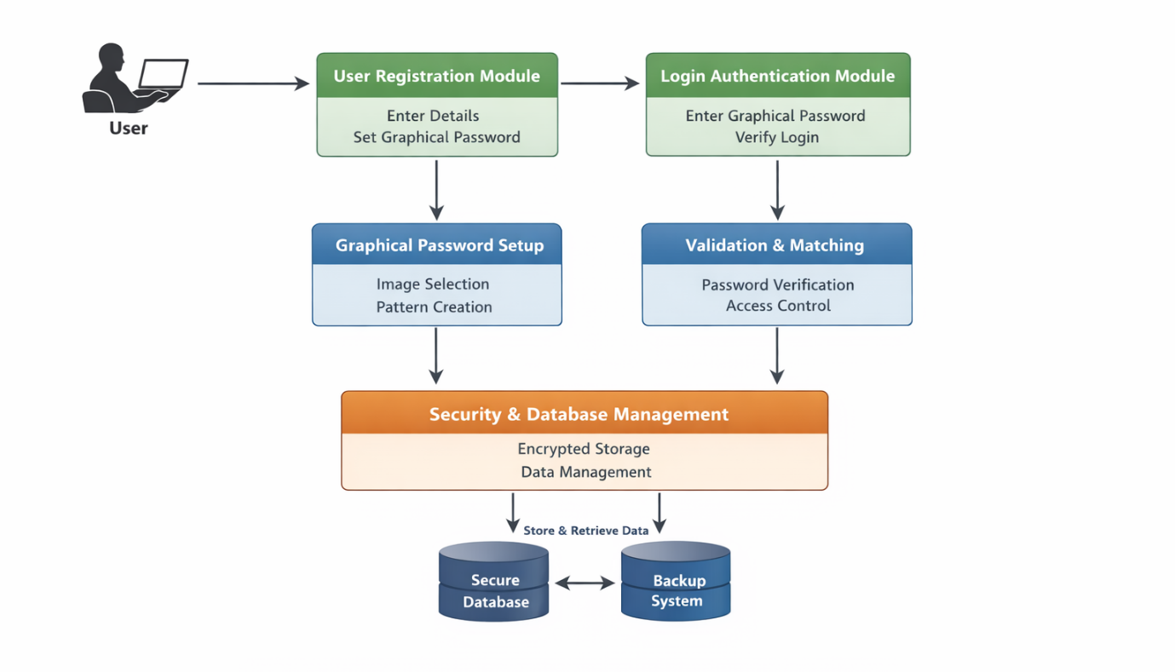
Fig.1 System Design of Graphical Password Authentication System

1. Class Diagram
Purpose: Shows the static structure of classes, attributes, methods, and relationships.
This class diagram represents the structure of the Graphical Password Authentication System, showing the main classes, their attributes, methods, and relationships.
At the top, the AuthS ystem class acts as the central controller of the system. It contains the main functions such as register (), login (), and verify (). This class coordinates all operations by interacting with other classes like User, Image Handler, and Hashing.
The User class stores user-related information. It has attributes such as username and password hash. Instead of storing the actual password, the system stores a hashed version for security purposes. This class represents each user in the system.
The Image Handler class is responsible for handling graphical inputs. It includes methods like load image () to display images, capture points () to record click positions on images, and capture words () if text-based graphical input is used. This class plays a key role in converting user actions into data.
Below it, the PointData class stores the details of the graphical password input. It contains attributes such as x and y coordinates (for click points) and word (if words are selected). This class helps in storing and comparing graphical password data accurately.
The Hashing class is used for security. It has a method generate hash () which converts the graphical password data into a secure hash format. This ensures that sensitive data is not stored in plain text.
Relationships:
- The Auth System interacts with:
  - User (for storing and retrieving user details)
  - Image Handler (for processing graphical input)
  - Hashing (for securing password data)
- The Image Handler is connected to PointData, as it generates and uses coordinate data for authentication.

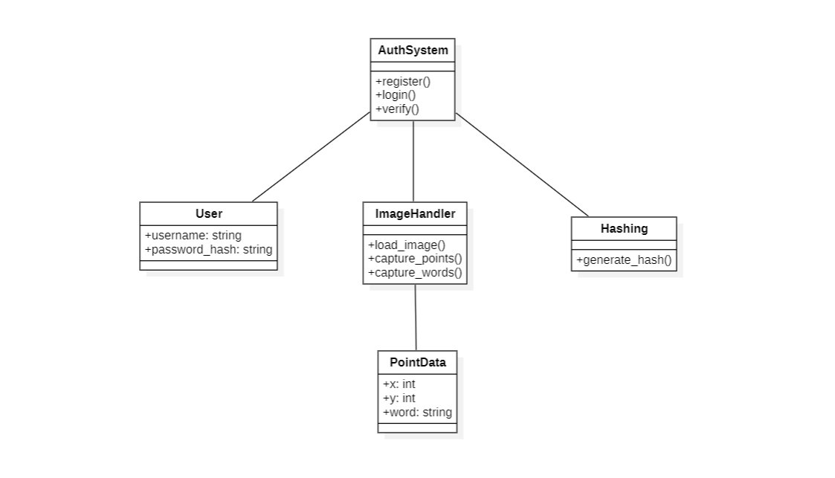
Fig. 2 Class diagram for graphical password authentication system

2. Use Case Diagram
Purpose: Describes system functionality from a user perspective.
This diagram represents how the user interacts with the system through different functionalities like registration and login.
The diagram has one main actor, which is the User. The user performs two primary actions: Register and Login.
1. Register Use Case
The Register process allows a new user to create an account in the system. It includes three sub-processes (shown using «include» relationships):
- Select Image: The user selects an image that will be used for graphical authentication.
- Click Points: The user clicks specific points on the selected image, which act as part of the password.
- Enter Word: The user may also enter a word or text as an additional security layer.
These steps are mandatory parts of the registration process, which is why they are connected using «include».
2. Login Use Case
The Login process is used by existing users to access the system. It also includes multiple sub-processes:
- Click Points: The user must click the same points on the image as chosen during registration.
- Enter Word: The user enters the same word used during registration.
- Verify Password: The system checks whether the entered graphical password matches the stored data.
If all inputs match correctly, the user is successfully authenticated; otherwise, access is denied.

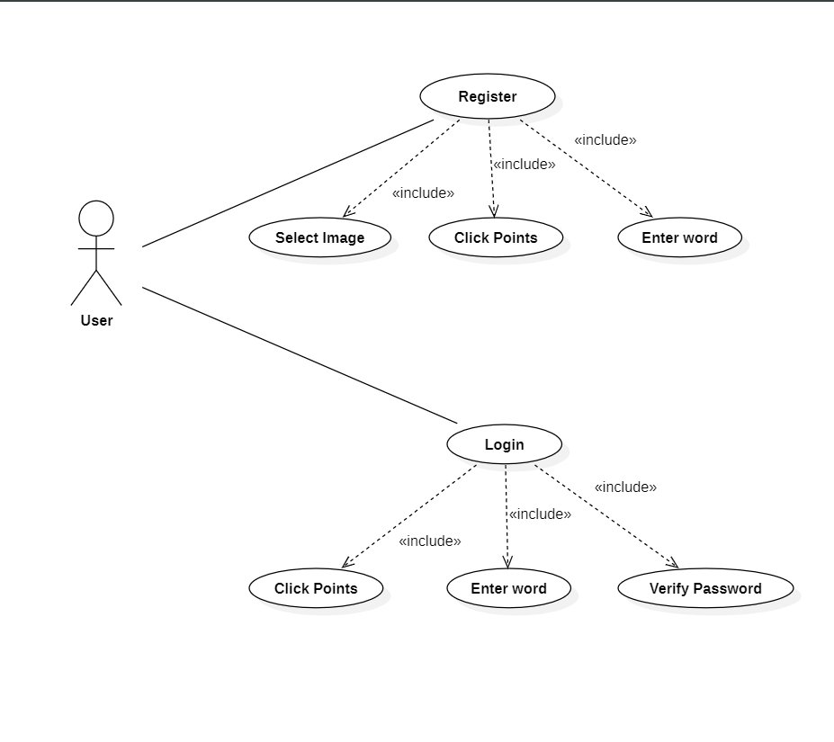
Fig.3 Usecase diagram of graphical password authentication system

3. Sequence Diagram
Purpose: Illustrates dynamic interactions between components over time.
The diagram shows step-by-step interaction where the user registers by creating a graphical password, and during login, the system verifies it by comparing hash values stored in the database.”
1. Registration Process
- Register: The User sends a registration request to the System.
- Select Image: The user selects an image for graphical password.
- Show Image: The System displays the selected image to the user.
- Click Points & Enter Words: The user clicks specific points on the image and enters a word.
- Generate Hash: The System converts this input into a secure hash value.
- Store: The generated hash is stored in the Database.
- Registration Success: The System confirms successful registration to the user.
2. Login Process
- Login: The User sends a login request to the System.
- Show Image: The System displays the image again for authentication.
- Click Points & Enter Words: The user repeats the same graphical password (clicks and word).
- Generate Hash: The System generates a hash from the entered input.
- Compare Hash: The System compares the generated hash with the stored hash in the Database.
- Login Success/Failure: If both hashes match, login is successful; otherwise, access is denie
. 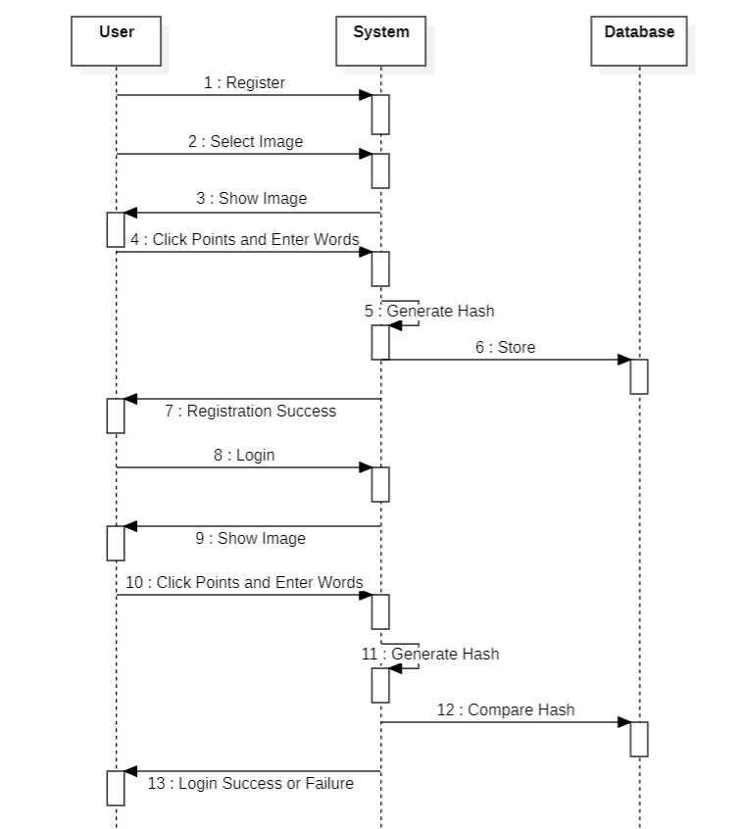
Fig. 4 Sequence diagram for graphical password authentication system

- Activity Diagram
This activity diagram represents the overall workflow of the system, showing step-by-step processes for both registration and login.
1. Start and Menu
- The process begins at the start node.
- The system displays a Menu, where the user chooses between Register and Login.
- Based on the User Choice, the flow splits into two paths.
2. Registration Process (Left Side)
If the user selects Register, the following steps occur:
- Select Image – The user chooses an image for the graphical password.
- Show Image – The system displays the selected image.
- Click Points & Enter Words – The user clicks specific points and enters a word.
- Generate Hash – The system converts this input into a secure hash value.
- Store Hash – The hash is stored in the database.
- Registration Success – A success message is displayed.
- The process ends.
3. Login Process (Right Side)
If the user selects Login, the system follows these steps:
- Display Image – The system shows the image used during registration.
- Click Points & Enter Words – The user repeats the same graphical password.
- Generate Hash – The system generates a hash from the input.
- Compare – The generated hash is compared with the stored hash.
- Decision (Match?)
  - If Yes → Success (User is authenticated)
  - If No → Denied (Access is rejected)
- The process ends.

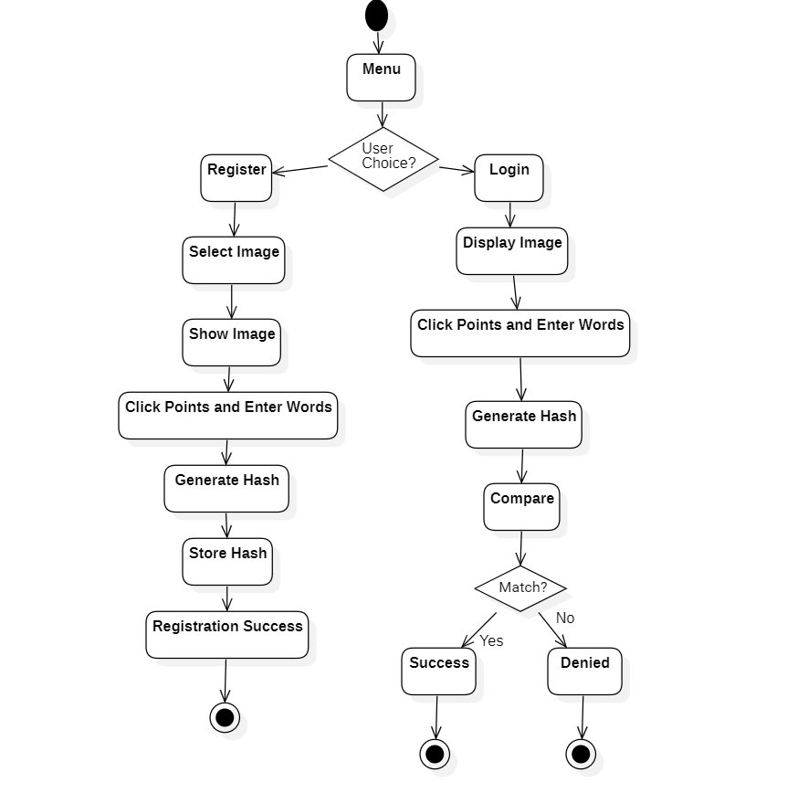
Fig. 5 Activity diagram for graphical password authentication system

8. SOURCE CODE
import tkinter as tk
from register import register
from login import login
def open_register():
register()
def open_login():
login()
root = tk.Tk()
root.title("Graphical Password Authentication")
root.geometry("400x300")
root.configure(bg="#1e1e2f")
title = tk.Label(root, text="Graphical Password System",
font=("Arial", 16, "bold"),
bg="#1e1e2f", fg="white")
title.pack(pady=30)
btn_register = tk.Button(root, text="Register",
command=open_register,
width=20, height=2,
bg="#4CAF50", fg="white")
btn_register.pack(pady=10)
btn_login = tk.Button(root, text="Login",
command=open_login,
width=20, height=2,
bg="#2196F3", fg="white")
btn_login.pack(pady=10)
btn_exit = tk.Button(root, text="Exit",
command=root.destroy,
width=20, height=2,
bg="#f44336", fg="white")
btn_exit.pack(pady=10)
root.mainloop()
import os
BASE_DIR = os.path.dirname(os.path.abspath(__file__))
# 📁 Paths
ASSETS_PATH = os.path.join(BASE_DIR, "assets")
DB_PATH = os.path.join(BASE_DIR, "database", "users.txt")
# ⚙️ Settings
GRID_SIZE = 20
TOLERANCE = 20
import cv2
import shutil
import os
from tkinter import Tk, filedialog, simpledialog, messagebox
from utils import generate_hash, combine_data
from config import ASSETS_PATH, DB_PATH, GRID_SIZE
root = Tk()
root.withdraw()
points = []
words = []
img = None
# ✅ FINAL BEST RESIZE
def resize_image(img):
screen_width = 1200
screen_height = 700
h, w = img.shape[:2]
if w <= screen_width and h <= screen_height:
return img
scale = min(screen_width / w, screen_height / h)
new_w = int(w * scale)
new_h = int(h * scale)
return cv2.resize(img, (new_w, new_h))
def setup_environment():
os.makedirs(ASSETS_PATH, exist_ok=True)
os.makedirs(os.path.dirname(DB_PATH), exist_ok=True)
if not os.path.exists(DB_PATH):
open(DB_PATH, 'w').close()
def select_image():
root.lift()
root.attributes('-topmost', True)
return filedialog.askopenfilename(title="Select Image")
def click_event(event, x, y, flags, param):
global img
if event == cv2.EVENT_LBUTTONDOWN:
temp = img.copy()
cv2.circle(temp, (x, y), 10, (0, 0, 255), 2)
cv2.imshow("Registration", temp)
cv2.waitKey(300)
cv2.imshow("Registration", img)
word = simpledialog.askstring("Input", f"Enter word for ({x},{y})")
if word:
points.append((x, y))
words.append(word)
def register():
global img, points, words
points = []
words = []
setup_environment()
messagebox.showwarning("Warning",
"Do NOT use personal images (family/friends)")
image_path = select_image()
if not image_path:
return
saved_path = os.path.join(ASSETS_PATH, "user_image.jpg")
shutil.copy(image_path, saved_path)
img = cv2.imread(saved_path)
if img is None:
messagebox.showerror("Error", "Image load failed!")
return
img = resize_image(img)
cv2.namedWindow("Registration", cv2.WINDOW_NORMAL)
cv2.resizeWindow("Registration", 1200, 700)
cv2.imshow("Registration", img)
cv2.setMouseCallback("Registration", click_event)
while True:
key = cv2.waitKey(1)
if key == 13:
break
elif key == 27:
cv2.destroyAllWindows()
return
if cv2.getWindowProperty("Registration", cv2.WND_PROP_VISIBLE) < 1:
break
cv2.destroyAllWindows()
if len(points) == 0:
messagebox.showerror("Error", "No points selected!")
return
combined = combine_data(points, words, GRID_SIZE)
hashed = generate_hash(combined)
with open(DB_PATH, "w") as f:
f.write(saved_path + "\n")
f.write(hashed)
messagebox.showinfo("Success", "Registration Successful!")
import cv2
import os
from tkinter import Tk, simpledialog, messagebox
from utils import generate_hash, combine_data
from config import DB_PATH, GRID_SIZE
root = Tk()
root.withdraw()
points = []
words = []
img = None
# ✅ SAME RESIZE
def resize_image(img):
screen_width = 1200
screen_height = 700
h, w = img.shape[:2]
if w <= screen_width and h <= screen_height:
return img
scale = min(screen_width / w, screen_height / h)
new_w = int(w * scale)
new_h = int(h * scale)
return cv2.resize(img, (new_w, new_h))
def setup_environment():
os.makedirs(os.path.dirname(DB_PATH), exist_ok=True)
if not os.path.exists(DB_PATH):
open(DB_PATH, 'w').close()
def click_event(event, x, y, flags, param):
global img
if event == cv2.EVENT_LBUTTONDOWN:
temp = img.copy()
cv2.circle(temp, (x, y), 10, (0, 255, 0), 2)
cv2.imshow("Login", temp)
cv2.waitKey(300)
cv2.imshow("Login", img)
word = simpledialog.askstring("Input", f"Enter word for ({x},{y})")
if word:
points.append((x, y))
words.append(word)
def login():
global img, points, words
points = []
words = []
setup_environment()
try:
with open(DB_PATH, "r") as f:
lines = f.readlines()
if len(lines) < 2:
messagebox.showwarning("Warning", "No user registered!")
return
image_path = lines[0].strip()
stored_hash = lines[1].strip()
except:
messagebox.showwarning("Warning", "No user registered!")
return
img = cv2.imread(image_path)
if img is None:
messagebox.showerror("Error", "Image load failed!")
return
img = resize_image(img)
cv2.namedWindow("Login", cv2.WINDOW_NORMAL)
cv2.resizeWindow("Login", 1200, 700)
cv2.imshow("Login", img)
cv2.setMouseCallback("Login", click_event)
while True:
key = cv2.waitKey(1)
if key == 13:
break
elif key == 27:
cv2.destroyAllWindows()
return
if cv2.getWindowProperty("Login", cv2.WND_PROP_VISIBLE) < 1:
break
cv2.destroyAllWindows()
combined = combine_data(points, words, GRID_SIZE)
hashed = generate_hash(combined)
if hashed == stored_hash:
messagebox.showinfo("Success", "Login Successful!")
else:
messagebox.showerror("Error", "Access Denied!")
import hashlib
def generate_hash(data):
return hashlib.sha256(data.encode()).hexdigest()
def normalize_point(point, grid_size):
return (
point[0] // grid_size * grid_size,
point[1] // grid_size * grid_size
)
def combine_data(points, words, grid_size):
combined = ""
for i in range(len(points)):
p = normalize_point(points[i], grid_size)
combined += f"{p[0]},{p[1]}:{words[i]}|"
return combined

9. SYSTEM STUDY
9.1 FEASIBILITY STUDY
The feasibility study evaluates whether the proposed Graphical Password Authentication system is practical, cost-effective, and beneficial to implement. It includes different types of feasibility analysis:
v9.1.1 FEASIBILITY STUDY FACTORS
1. TECHNICAL FEASIBILITY
The system is technically feasible as it uses commonly available technologies such as Python, image processing libraries, and databases. The required tools like NumPy, OpenCV, and basic GUI frameworks are easy to implement. The system does not require highly advanced hardware and can run on standard computers or laptops. Hence, the technical requirements are easily achievable.
Additionally, the development environment is simple and supports cross-platform execution. The system can be easily integrated with existing applications without major changes. Regular updates and maintenance can also be handled without technical difficulty.
2. OPERATIONAL FEASIBILITY
The system is user-friendly and easy to operate. Users can easily understand and use graphical passwords instead of remembering complex text passwords. The interface is simple, and the system improves user experience while maintaining security. Therefore, it is operationally feasible.
Training requirements for users are minimal due to its intuitive design. The system reduces user errors and login failures. It can be effectively used by people with basic computer knowledge.
3. ECONOMIC FEASIBILITY
The project is cost-effective because it mainly uses open-source tools and software. There is no need for expensive hardware or licensed software. Development and maintenance costs are low, making it economically feasible for both small-scale and large-scale applications.
Moreover, the system reduces costs related to password recovery and security breaches. It minimizes the need for additional security infrastructure. Overall, it provides high security benefits at a low implementation cost.
4. SECURITY FEASIBILITY
The system enhances security by using graphical passwords and hashing techniques. It reduces risks like brute force attacks, guessing, and shoulder surfing. Since passwords are stored in encrypted form, data security is maintained effectively.
It also provides an additional layer of protection through image-based authentication. Unauthorized access becomes more difficult compared to text passwords. The system can be further improved by adding multi-factor authentication.
5. TIME FEASIBILITY
The project can be developed within a limited time frame using available tools and technologies. The modules are simple and can be implemented step-by-step without requiring excessive time. Hence, it is time feasible.
Development can be completed in phases such as design, coding, and testing. Proper planning helps in meeting deadlines efficiently. Future enhancements can also be added without affecting the existing system timeline.
9.2 FEASIBILITY STUDY METHODOLOGY
To evaluate feasibility effectively, the following structured methodology was adopted:
1. Problem Identification
The first step in feasibility study methodology is identifying the problem in the existing system. Traditional text-based password systems have several issues such as weak security, difficulty in remembering passwords, and vulnerability to attacks like brute force and phishing. These limitations create a need for a more secure and user-friendly authentication system. Hence, the graphical password system is proposed as a solution.
2. Requirement Analysis
In this step, the system requirements are collected and analyzed. This includes understanding user needs, system functionalities, and security requirements. The system must allow users to register and log in using graphical passwords, ensure data protection, and provide a simple interface. Both functional and non-functional requirements are clearly defined to guide the development process.
3. Technical Feasibility Analysis
This step evaluates whether the required technology and tools are available to implement the system. The project uses technologies like Python, image processing libraries, and databases, which are easily accessible. The system can run on standard hardware without requiring special equipment. Therefore, it is technically feasible to develop and deploy the system.
4. Economic Feasibility Analysis
Economic feasibility focuses on the cost involved in developing and maintaining the system. Since the project uses open-source tools, the cost is very low. There is no need for expensive software or hardware. The benefits of improved security and usability outweigh the development cost, making the system economically feasible.
5. Operational Feasibility Analysis
This step checks whether the system will be accepted and used effectively by users. The graphical password system is easy to understand and use, even for non-technical users. It reduces the burden of remembering complex passwords and improves user experience. Hence, the system is operationally feasible.
6. Security Feasibility Analysis
Feasibility evaluates how well the system can protect user data. The proposed system uses Security graphical passwords and hashing techniques, which provide better protection compared to traditional methods. It reduces risks such as guessing and brute force attacks. Therefore, the system ensures strong security.
7. Time Feasibility Analysis
Time feasibility determines whether the project can be completed within the given time frame. The system is divided into modules, making development easier and faster. With proper planning and implementation, the project can be completed within the scheduled time. Thus, it is time feasible.
8. Final Decision
After analyzing all the above factors, a final decision is made regarding the implementation of the system. Since the project satisfies technical, economic, operational, security, and time feasibility, it is considered suitable for development. The system is approved as a practical and efficient solution

10. SYSTEM TESTING
System testing is the process of evaluating the complete system to ensure that it works correctly and meets all the specified requirements. In the Graphical Password Authentication system, testing is performed to verify both functionality and security of the application.
PURPOSE OF SYSTEM TESTING
The main objectives of system testing include:
- To verify system functionality – Ensures all modules like registration, login, authentication work correctly.
- To detect errors and bugs – Identifies issues in the system before deployment.
- To ensure security and reliability – Checks protection against unauthorized access and system failures.
- To validate user requirements – Confirms that the system meets user needs and is easy to use.
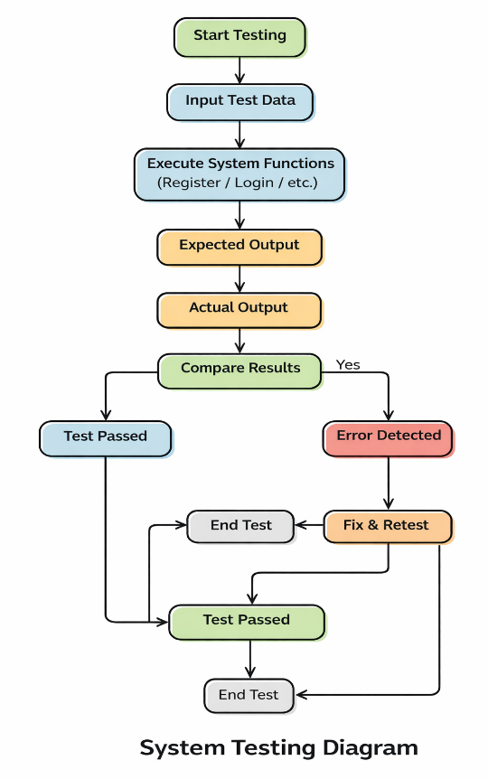

Fig. 6 System Testing
10.1 TYPES OF SYSTEM TESTING
1. Unit Testing
In unit testing, individual modules such as user registration, login authentication, image processing, and hashing are tested separately. Each module is checked to ensure it performs its intended function correctly without errors.
2. Integration Testing
Integration testing is performed to verify the interaction between different modules. For example, the connection between the user interface, authentication module, and database is tested to ensure smooth data flow and proper communication.
3. System Testing
In this phase, the complete system is tested as a whole. It checks whether all modules work together correctly, including registration, login, password verification, and data storage. The system is tested under different scenarios to ensure reliability.
4. Functional Testing
Functional testing ensures that all features of the system work according to the requirements. It verifies operations such as image selection, click point capture, password creation, and authentication process.
5. Security Testing
Security testing is performed to ensure that the system is protected against threats. It checks for vulnerabilities such as brute force attacks, unauthorized access, and data leakage. The effectiveness of hashing and encryption is also tested.
6. User Acceptance Testing (UAT)
In this phase, the system is tested by actual users to ensure it meets their expectations. Users verify whether the system is easy to use, efficient, and reliable for authentication purposes.
TESTING ENVIRONMENT AND SETUP
- Platform: Python (with VS Code / Jupyter Notebook): Used as the development platform to build and run the graphical password authentication system.
- Libraries: OpenCV, NumPy, Tkinter, Hashlib
- Data Source: The system uses user-provided data such as selected images, click points, and words for authentication.
“System testing should be thorough, secure, and continuous to ensure reliable and error-free system performance.”

11. OUTPUT SCREENS

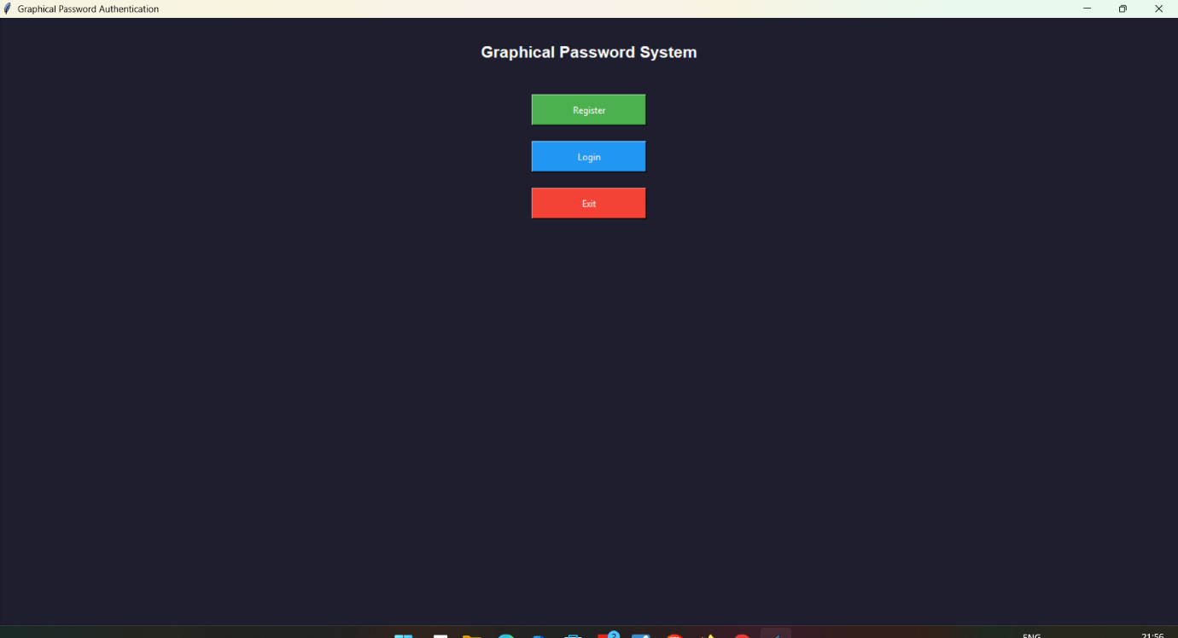
Output screen displaying the graphical password authentication system with options to register, log in, and exit.

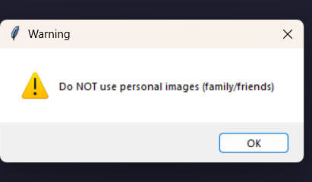
Warning message alerting users not to use personal images for authentication.

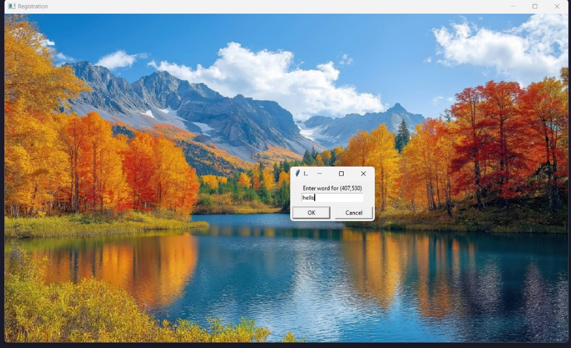
Registration screen where the user selects a graphical password by entering a word on an image.

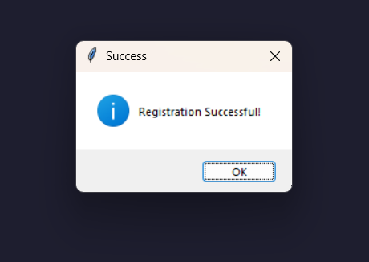
A graphical password authentication system that confirms successful user registration through a simple visual interface.
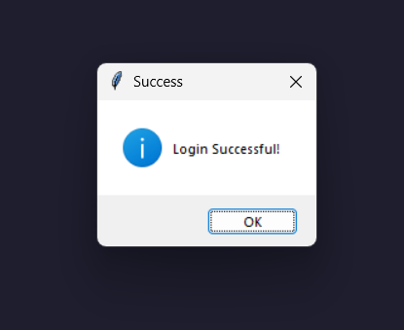
A visually engaging graphical password authentication system that ensures secure access with smooth and satisfying login confirmation.

12. CONCLUSION
In today’s digital world, ensuring secure access to systems and personal data is of paramount importance. Traditional text-based passwords, though widely used, are increasingly vulnerable to attacks such as phishing, keylogging, and brute-force methods. This project, Graphical Password Authentication, focuses on providing a more secure and user-friendly alternative by leveraging the human ability to recognize and recall images more effectively than complex alphanumeric strings. By allowing users to select and interact with images as their authentication mechanism, the system significantly reduces the risk of unauthorized access while improving memorability.
Through rigorous system testing, including functional, performance, and security testing, the project demonstrates that graphical authentication can be a feasible and effective approach for enhancing security in modern applications. The testing environment, realistic test data, and regression testing ensure that the system performs reliably under different scenarios and maintains data integrity at all times. Additionally, recommendations from the testing phase, such as continuous monitoring, regular updates, and user education, help maintain long-term security and usability.
In conclusion, this project highlights the potential of graphical password systems as a secure, intuitive, and practical alternative to conventional text-based authentication. By combining security principles with human cognitive strengths, the system not only addresses common vulnerabilities but also provides a positive user experience. This project can serve as a foundation for further research and development in secure authentication methods, paving the way for innovative solutions in cybersecurity. Overall, the system meets its objectives of enhancing security, ensuring usability, and providing a scalable solution suitable for real-world applications.

13. FUTURE ENHANCEMENTS
While the current system effectively leverages a Transformer-based architecture for stock price prediction, several enhancements can improve its robustness, accuracy, and real-world applicability. These include technical upgrades, user experience improvements, and financial modeling extensions.
12.1 Technical Enhancements:
The system can be upgraded with stronger encryption algorithms and more secure authentication protocols to enhance data protection. Implementing multi-factor authentication by combining graphical passwords with biometrics or OTPs can significantly reduce unauthorized access. Additionally, integrating AI-based anomaly detection can help in identifying suspicious login attempts in real time, making the system more robust against attacks.
12.2 Data Enhancements:
Future improvements can include expanding the image dataset to cover more diverse and high-resolution images to improve memorability and resistance to pattern-guessing attacks. The system can also leverage user behaviour data to personalize image choices and patterns, improving user experience while maintaining security. Incorporating dynamic or context-aware image selection will reduce vulnerability to shoulder surfing and replay attacks.
12.3 Model and Training Enhancements:
The authentication model can be enhanced by implementing deep learning techniques to analyse user interaction patterns, such as click sequences or gesture dynamics. Training the model on larger and more varied datasets will improve accuracy in verifying genuine users and detecting anomalies. Continuous model updates and reinforcement learning can help the system adapt to evolving user behaviour and security threats over time.
12.4 Deployment and User Interface Enhancements:
Future deployment can focus on cross-platform compatibility, allowing seamless access on desktops, mobile devices, and web applications. The user interface can be refined with intuitive gestures, drag-and-drop patterns, and touch-friendly designs for mobile users. Real-time feedback, customizable themes, and accessibility features will enhance usability and user satisfaction without compromising security.
12.5 Business and Financial Enhancements:
From a business perspective, the system can be offered as a subscription-based security service for enterprises, providing scalable authentication solutions across multiple applications. Reducing operational costs through cloud-based deployment and automated monitoring can increase profitability. Additionally, integrating analytics and reporting features can provide businesses with actionable insights, creating new revenue opportunities through security consulting and premium service plans.

14. REFERENCES
- William Stallings and Lawrie Brown. Conmater Security: Principle and Practices. Pearson Education, 2008,
- Susan Wiedenbeck, Jim Waters, Jean-Camille Birget, Alex Brodskiy, and Nasir Memon. Passpoints: design and longitudinal evaluation of a graphical password system International Journal of Human-Computer Studies, 63:102-127, July 2005.
- Robert Morris and Ken Thompson. Password security: a case history. Communications of the ACM, 22-594-597, November 1979.
- Daniel V. Klein. Foiling the Cracker. A Survey of, and Improvements to, Password Security. In Proceedings of the 2nd USENIX UNIX Security Workshop, 1990.
- Eugene H. Spafford. Observing reusable password chances. In Proceedings of the 3nd Security Sympo siam. Urenix, pages 299-312, 1992.
- Sigmund N. Porter. A password extension for improved human factors. Computers & Security, 1(1):54 56. 1982.
- Xiaoyuan Suo, Ying Zhu, and G. Sentt Owen. Graphical passwords: A survey. In Proceedings of Annual Computer Security Applications Conference, pages 463-472, 2005.
- Antonella De Angeli, Lynne Lynne Coventry, Graham John-son, and Karen Renaud, Is a picture really worth a thousand words? exploring the feasibility of graphical authentication systems international Journal of Human-Computer Studies, 63:128-152, July 2005.
- Real User Corporation. The science behind passfaces, June 2004.
- G. E. Blonder. Graphical password, US. Patent 5559961, Lucent Technologies, Inc. (Murray Hill, NI), August 1995

